Annica Black-Schaffer - Uppsala University

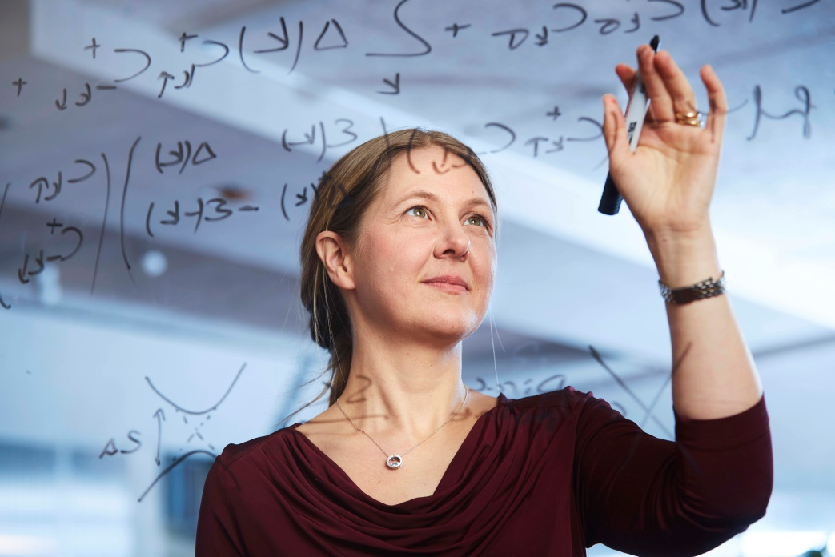

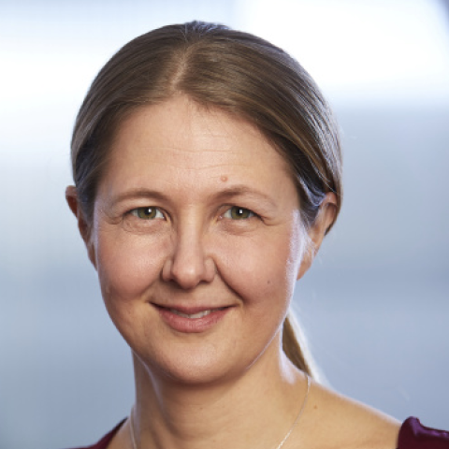

Piotr Deuar, IFPAN, Warsaw
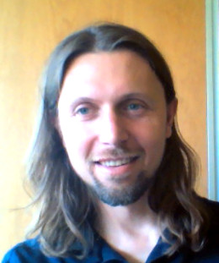

Tadeusz Domański, UMCS, Lublin

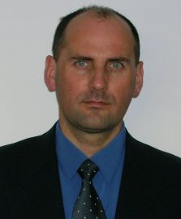

Dariusz Kaczorowski

Institute of Low Temperature and Structure Research, PAS, Wrocław
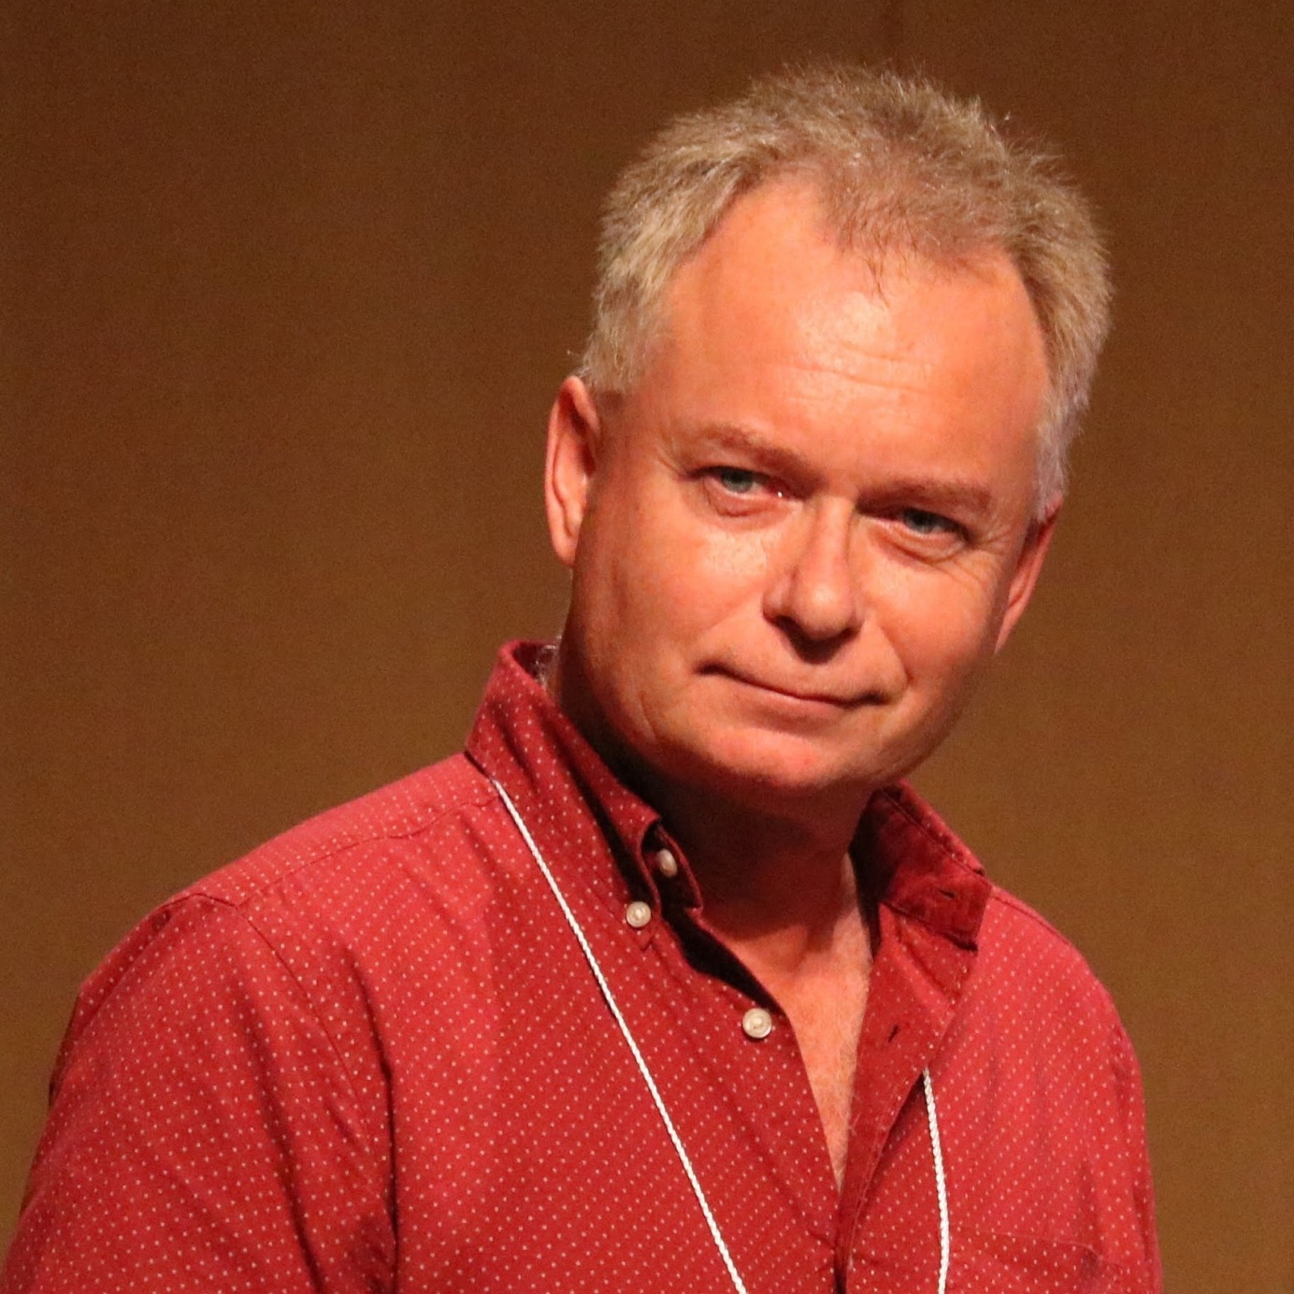

Carmine Ortix
Salerno University

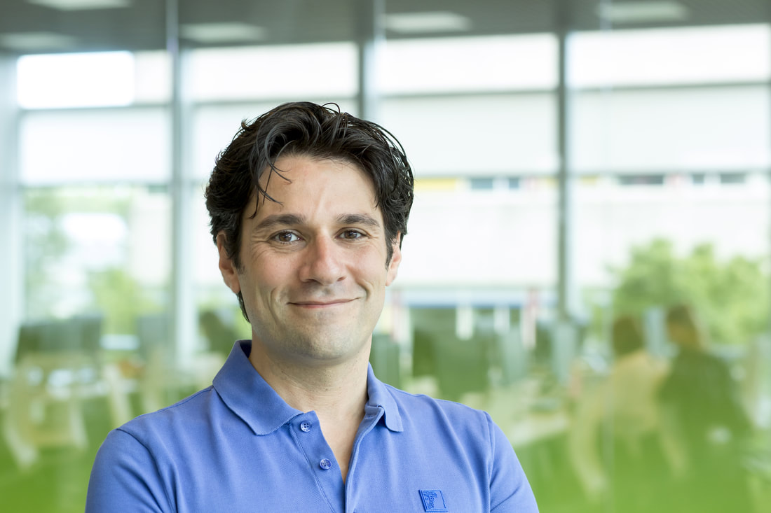

Oliver Rader

Helmholtz-Zentrum Berlin

